SCHOOL OF COMPUTER SCIENCE AND ARTIFICIAL INTELLIGENCE |  |  |  |  | DEPARTMENT OF COMPUTER SCIENCE ENGINEERING
Program Name: B. Tech |  |  |  | Assignment Type: Lab |  |  | Academic Year:2025-2026
Course Coordinator Name |  |  |  | Venkataramana Veeramsetty
Instructor(s) Name |  |  |  | Dr. V. Venkataramana (Co-ordinator)  Dr. T. Sampath Kumar  Dr. Pramoda Patro  Dr. Brij Kishor Tiwari  Dr.J.Ravichander  Dr. Mohammand Ali Shaik  Dr. Anirodh Kumar  Mr. S.Naresh Kumar  Dr. RAJESH VELPULA  Mr. Kundhan Kumar  Ms. Ch.Rajitha  Mr. M Prakash  Mr. B.Raju  Intern 1 (Dharma teja)  Intern 2 (Sai Prasad)  Intern 3 (Sowmya)  NS_2 ( Mounika)
Course Code |  |  | 24CS002PC215 | Course Title |  | AI Assisted Coding
Year/Sem |  |  | II/I | Regulation |  | R24
Date and Day  of Assignment |  |  | Week5 - Monday | Time(s)
Duration |  |  | 2 Hours | Applicable to  Batches
AssignmentNumber:10.1(Present assignment number)/24(Total number of assignments)
 | Q.No. | Question |  |  |  |  |  | Expected Time  to complete
 | 1 | Lab 10 – Code Review and Quality: Using AI to Improve Code Quality and Readability  Lab Objectives  - Use AI for automated code review and quality enhancement.  - Identify and fix syntax, logical, performance, and security issues in Python code.  - Improve readability and maintainability through structured refactoring and comments.  - Apply prompt engineering for targeted improvements.  - Evaluate AI-generated suggestions against PEP 8 standards and software engineering best practices  Task Description #1 – Syntax and Logic Errors  Task: Use AI to identify and fix syntax and logic errors in a faulty Python script.  Sample Input Code:  # Calculate average score of a student  def calc_average(marks):  total = 0  for m in marks:  total += m  average = total / len(marks)  return avrage # Typo here  marks = [85, 90, 78, 92]  print("Average Score is ", calc_average(marks)  Expected Output:  - Corrected and runnable Python code with explanations of the fixes.  Prompt:  identify and fix syntax and logic errors in a faulty Python script  Corrected Code:  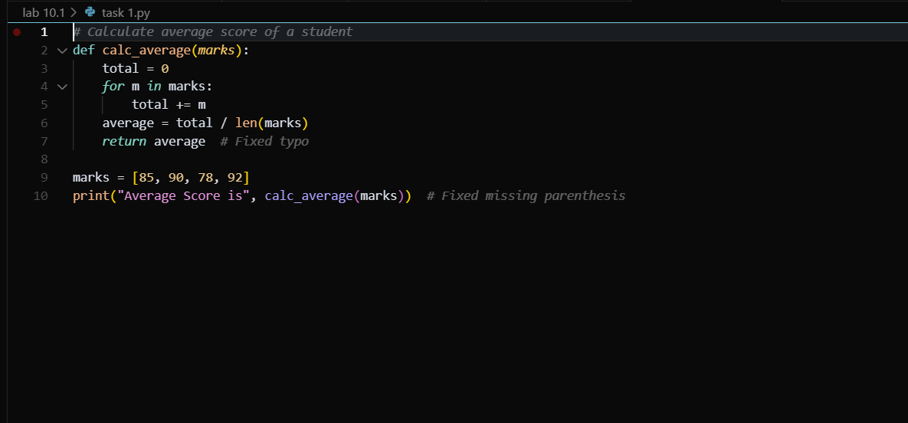  Corrected Output:  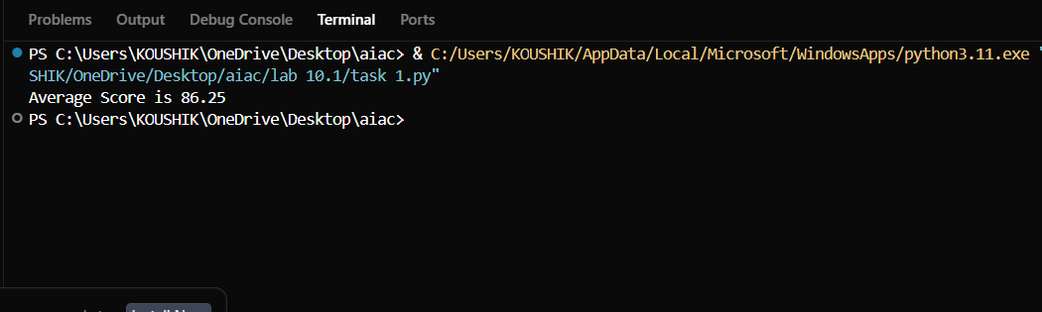  Task Description #2 – PEP 8 Compliance  Task: Use AI to refactor Python code to follow PEP 8 style guidelines.  Sample Input Code:  def area_of_rect(L,B):return L*B  print(area_of_rect(10,20))  Expected Output:  - Well-formatted PEP 8-compliant Python code.  Prompt:  rewrite the code with Well-formatted PEP 8-compliant Python code, write the proper names and raise error when the input is wrong and add doc strings to explain the code  Well-formatted Code:  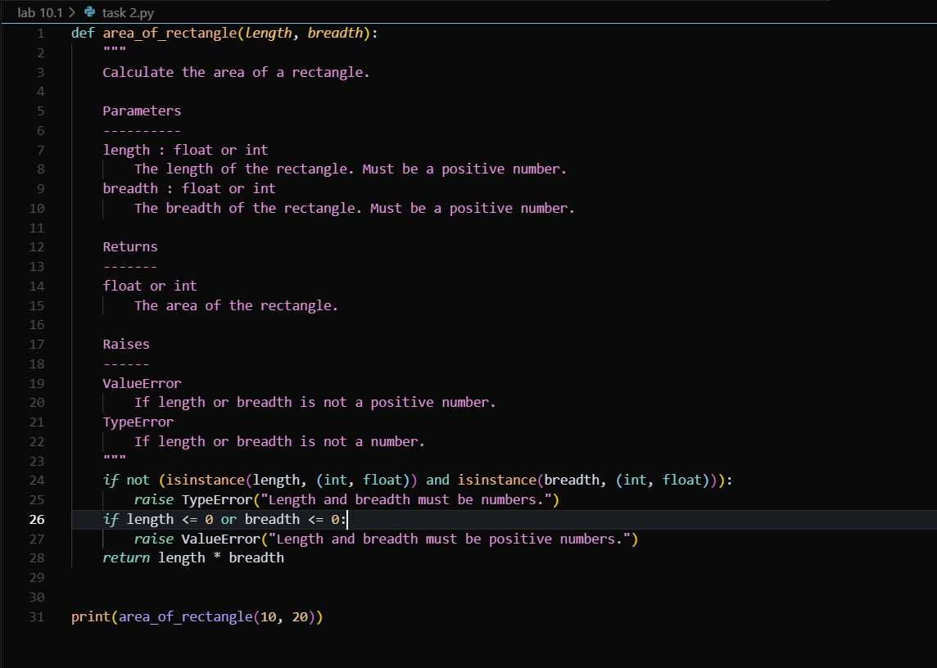  Output:  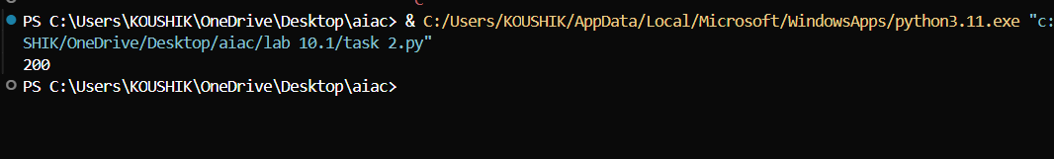  Task Description #3 – Readability Enhancement  Task: Use AI to make code more readable without changing its logic.  Sample Input Code:  def c(x,y):  return x*y/100  a=200  b=15  print(c(a,b))  Expected Output:  - Python code with descriptive variable names, inline comments, and clear formatting.  Prompt:  make the code more readable without changing its logic  enhanced Code:  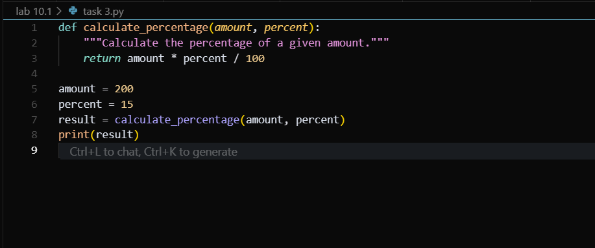  Output:  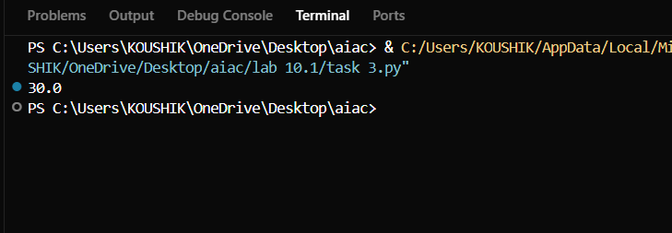  Task Description #4 – Refactoring for Maintainability  Task: Use AI to break repetitive or long code into reusable functions.  Sample Input Code:  students = ["Alice", "Bob", "Charlie"]  print("Welcome", students[0])  print("Welcome", students[1])  print("Welcome", students[2])  Expected Output:  - Modular code with reusable functions.  Prompt:  break the repetitive code into reusable functions and use the correct logic  Refactored Code:  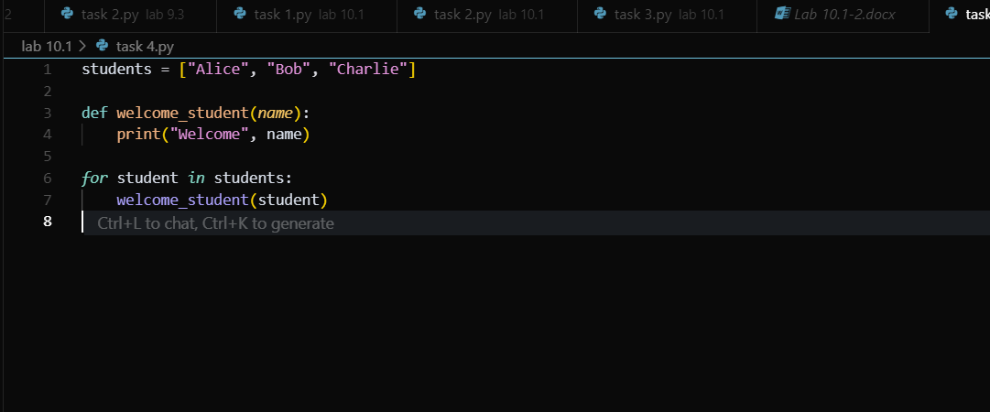  Output:  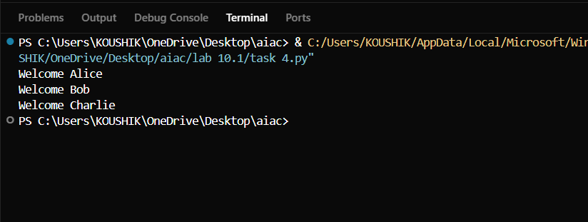  Task Description #5 – Performance Optimization  Task: Use AI to make the code run faster.  Sample Input Code:  # Find squares of numbers  nums = [i for i in range(1,1000000)]  squares = []  for n in nums:  squares.append(n**2)  print(len(squares))  Expected Output:  - Optimized code using list comprehensions or vectorized operations.  Prompt:  make the code run faster by using list comprehensions or vectorized operations and check the execution time.  Optimized code:  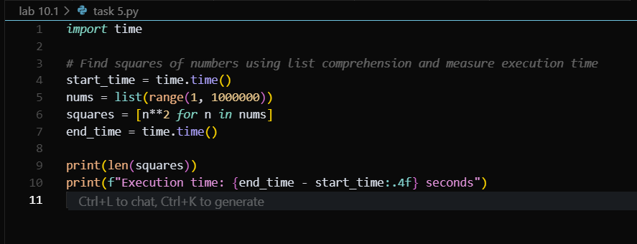  Output:  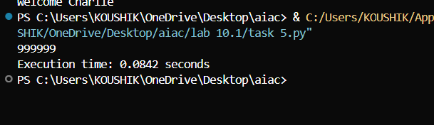  Task Description #6 – Complexity Reduction  Task: Use AI to simplify overly complex logic.  Sample Input Code:  def grade(score):  if score >= 90:  return "A"  else:  if score >= 80:  return "B"  else:  if score >= 70:  return "C"  else:  if score >= 60:  return "D"  else:  return "F"  Expected Output:  - Cleaner logic using elif or dictionary mapping.  Prompt:  simplify the overly complex logic by using elif and write the sample input and return the output so that it can print the output  simplified code:  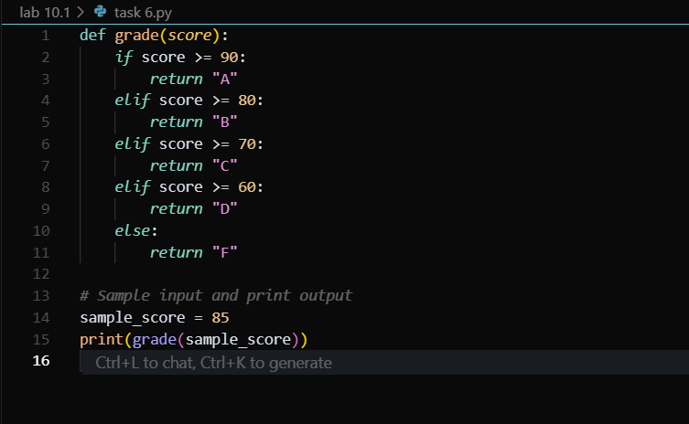  Output:  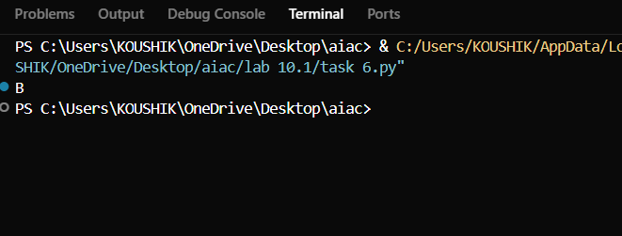 |  |  |  |  |  | Week5 - Monday

